Chapter 13: Human-in-the-Loop

The Human-in-the-Loop (HITL) pattern represents a pivotal strategy in the development and deployment of Agents. It deliberately interweaves the unique strengths of human cognition—such as judgment, creativity, and nuanced understanding—with the computational power and efficiency of AI. This strategic integration is not merely an option but often a necessity, especially as AI systems become increasingly embedded in critical decision-making processes.

The core principle of HITL is to ensure that AI operates within ethical boundaries, adheres to safety protocols, and achieves its objectives with optimal effectiveness. These concerns are particularly acute in domains characterized by complexity, ambiguity, or significant risk, where the implications of AI errors or misinterpretations can be substantial. In such scenarios, full autonomy—where AI systems function independently without any human intervention—may prove to be imprudent. HITL acknowledges this reality and emphasizes that even with rapidly advancing AI technologies, human oversight, strategic input, and collaborative interactions remain indispensable.

The HITL approach fundamentally revolves around the idea of synergy between artificial and human intelligence. Rather than viewing AI as a replacement for human workers, HITL positions AI as a tool that augments and enhances human capabilities. This augmentation can take various forms, from automating routine tasks to providing data-driven insights that inform human decisions. The end goal is to create a collaborative ecosystem where both humans and AI Agents can leverage their distinct strengths to achieve outcomes that neither could accomplish alone.

In practice, HITL can be implemented in diverse ways. One common approach involves humans acting as validators or reviewers, examining AI outputs to ensure accuracy and identify potential errors. Another implementation involves humans actively guiding AI behavior, providing feedback or making corrections in real-time. In more complex setups, humans may collaborate with AI as partners, jointly solving problems or making decisions through interactive dialog or shared interfaces. Regardless of the specific implementation, the HITL pattern underscores the importance of maintaining human control and oversight, ensuring that AI systems remain aligned with human ethics, values, goals, and societal expectations.

# Human-in-the-Loop Pattern Overview

The Human-in-the-Loop (HITL) pattern integrates artificial intelligence with human input to enhance Agent capabilities. This approach acknowledges that optimal AI performance frequently requires a combination of automated processing and human insight, especially in scenarios with high complexity or ethical considerations. Rather than replacing human input, HITL aims to augment human abilities by ensuring that critical judgments and decisions are informed by human understanding.

HITL encompasses several key aspects: Human Oversight, which involves monitoring AI agent performance and output (e.g., via log reviews or real-time dashboards) to ensure adherence to guidelines and prevent undesirable outcomes. Intervention and Correction occurs when an AI agent encounters errors or ambiguous scenarios and may request human intervention; human operators can rectify errors, supply missing data, or guide the agent, which also informs future agent improvements. Human Feedback for Learning is collected and used to refine AI models, prominently in methodologies like reinforcement learning with human feedback, where human preferences directly influence the agent's learning trajectory. Decision Augmentation is where an AI agent provides analyses and recommendations to a human, who then makes the final decision, enhancing human decision-making through AI-generated insights rather than full autonomy. Human-Agent Collaboration is a cooperative interaction where humans and AI agents contribute their respective strengths; routine data processing may be handled by the agent, while creative problem-solving or complex negotiations are managed by the human. Finally, Escalation Policies are established protocols that dictate when and how an agent should escalate tasks to human operators, preventing errors in situations beyond the agent's capability.

Implementing HITL patterns enables the use of Agents in sensitive sectors where full autonomy is not feasible or permitted. It also provides a mechanism for ongoing improvement through feedback loops. For example, in finance, the final approval of a large corporate loan requires a human loan officer to assess qualitative factors like leadership character. Similarly, in the legal field, core principles of justice and accountability demand that a human judge retain final authority over critical decisions like sentencing, which involve complex moral reasoning.

### **Caveats:** Despite its benefits, the HITL pattern has significant caveats, chief among them being a lack of scalability. While human oversight provides high accuracy, operators cannot manage millions of tasks, creating a fundamental trade-off that often requires a hybrid approach combining automation for scale and HITL for accuracy. Furthermore, the effectiveness of this pattern is heavily dependent on the expertise of the human operators; for example, while an AI can generate software code, only a skilled developer can accurately identify subtle errors and provide the correct guidance to fix them. This need for expertise also applies when using HITL to generate training data, as human annotators may require special training to learn how to correct an AI in a way that produces high-quality data. Lastly, implementing HITL raises significant privacy concerns, as sensitive information must often be rigorously anonymized before it can be exposed to a human operator, adding another layer of process complexity.

# Practical Applications & Use Cases

The Human-in-the-Loop pattern is vital across a wide range of industries and applications, particularly where accuracy, safety, ethics, or nuanced understanding are paramount.

* **Content Moderation:** AI agents can rapidly filter vast amounts of online content for violations (e.g., hate speech, spam). However, ambiguous cases or borderline content are escalated to human moderators for review and final decision, ensuring nuanced judgment and adherence to complex policies.
* **Autonomous Driving:** While self-driving cars handle most driving tasks autonomously, they are designed to hand over control to a human driver in complex, unpredictable, or dangerous situations that the AI cannot confidently navigate (e.g., extreme weather, unusual road conditions).
* **Financial Fraud Detection:** AI systems can flag suspicious transactions based on patterns. However, high-risk or ambiguous alerts are often sent to human analysts who investigate further, contact customers, and make the final determination on whether a transaction is fraudulent.
* **Legal Document Review:** AI can quickly scan and categorize thousands of legal documents to identify relevant clauses or evidence. Human legal professionals then review the AI's findings for accuracy, context, and legal implications, especially for critical cases.
* **Customer Support (Complex Queries):** A chatbot might handle routine customer inquiries. If the user's problem is too complex, emotionally charged, or requires empathy that the AI cannot provide, the conversation is seamlessly handed over to a human support agent.
* **Data Labeling and Annotation:** AI models often require large datasets of labeled data for training. Humans are put in the loop to accurately label images, text, or audio, providing the ground truth that the AI learns from. This is a continuous process as models evolve.
* **Generative AI Refinement:** When an LLM generates creative content (e.g., marketing copy, design ideas), human editors or designers review and refine the output, ensuring it meets brand guidelines, resonates with the target audience, and maintains quality.
* **Autonomous Networks:** AI systems are capable of analyzing alerts and forecasting network issues and traffic anomalies by leveraging key performance indicators (KPIs) and identified patterns. Nevertheless, crucial decisions—such as addressing high-risk alerts—are frequently escalated to human analysts. These analysts conduct further investigation and make the ultimate determination regarding the approval of network changes.

This pattern exemplifies a practical method for AI implementation. It harnesses AI for enhanced scalability and efficiency, while maintaining human oversight to ensure quality, safety, and ethical compliance.

"Human-on-the-loop" is a variation of this pattern where human experts define the overarching policy, and the AI then handles immediate actions to ensure compliance. Let's consider two examples:

* **Automated financial trading system**: In this scenario, a human financial expert sets the overarching investment strategy and rules. For instance, the human might define the policy as: "Maintain a portfolio of 70% tech stocks and 30% bonds, do not invest more than 5% in any single company, and automatically sell any stock that falls 10% below its purchase price." The AI then monitors the stock market in real-time, executing trades instantly when these predefined conditions are met. The AI is handling the immediate, high-speed actions based on the slower, more strategic policy set by the human operator.
* **Modern call center**: In this setup, a human manager establishes high-level policies for customer interactions. For instance, the manager might set rules such as "any call mentioning 'service outage' should be immediately routed to a technical support specialist," or "if a customer's tone of voice indicates high frustration, the system should offer to connect them directly to a human agent." The AI system then handles the initial customer interactions, listening to and interpreting their needs in real-time. It autonomously executes the manager's policies by instantly routing the calls or offering escalations without needing human intervention for each individual case. This allows the AI to manage the high volume of immediate actions according to the slower, strategic guidance provided by the human operator.

# Hands-On Code Example

To demonstrate the Human-in-the-Loop pattern, an ADK agent can identify scenarios requiring human review and initiate an escalation process . This allows for human intervention in situations where the agent's autonomous decision-making capabilities are limited or when complex judgments are required. This is not an isolated feature; other popular frameworks have adopted similar capabilities. LangChain, for instance, also provides tools to implement these types of interactions.

| from google.adk.agents import Agent  from google.adk.tools.tool_context import ToolContext  from google.adk.callbacks import CallbackContext  from google.adk.models.llm import LlmRequest  from google.genai import types  from typing import Optional  # Placeholder for tools (replace with actual implementations if needed)  def troubleshoot_issue(issue: str) -> dict:  return {"status": "success", "report": f"Troubleshooting steps for {issue}."}  def create_ticket(issue_type: str, details: str) -> dict:  return {"status": "success", "ticket_id": "TICKET123"}  def escalate_to_human(issue_type: str) -> dict:  # This would typically transfer to a human queue in a real system  return {"status": "success", "message": f"Escalated {issue_type} to a human specialist."}  technical_support_agent = Agent(  name="technical_support_specialist",  model="gemini-2.0-flash-exp",  instruction="""  You are a technical support specialist for our electronics company.  FIRST, check if the user has a support history in state["customer_info"]["support_history"]. If they do, reference this history in your responses.  For technical issues:  1. Use the troubleshoot_issue tool to analyze the problem.  2. Guide the user through basic troubleshooting steps.  3. If the issue persists, use create_ticket to log the issue.  For complex issues beyond basic troubleshooting:  1. Use escalate_to_human to transfer to a human specialist.  Maintain a professional but empathetic tone. Acknowledge the frustration technical issues can cause, while providing clear steps toward resolution.  """,  tools=[troubleshoot_issue, create_ticket, escalate_to_human]  )  def personalization_callback(  callback_context: CallbackContext, llm_request: LlmRequest  ) -> Optional[LlmRequest]:  """Adds personalization information to the LLM request."""  # Get customer info from state  customer_info = callback_context.state.get("customer_info")  if customer_info:  customer_name = customer_info.get("name", "valued customer")  customer_tier = customer_info.get("tier", "standard")  recent_purchases = customer_info.get("recent_purchases", [])  personalization_note = (  f"\nIMPORTANT PERSONALIZATION:\n"  f"Customer Name: {customer_name}\n"  f"Customer Tier: {customer_tier}\n"  )  if recent_purchases:  personalization_note += f"Recent Purchases: {', '.join(recent_purchases)}\n"  if llm_request.contents:  # Add as a system message before the first content  system_content = types.Content(  role="system", parts=[types.Part(text=personalization_note)]  )  llm_request.contents.insert(0, system_content)  return None # Return None to continue with the modified request |
| --- |

This code offers a blueprint for creating a technical support agent using Google's ADK, designed around a HITL framework. The agent acts as an intelligent first line of support, configured with specific instructions and equipped with tools like troubleshoot_issue, create_ticket, and escalate_to_human to manage a complete support workflow. The escalation tool is a core part of the HITL design, ensuring complex or sensitive cases are passed to human specialists.

A key feature of this architecture is its capacity for deep personalization, achieved through a dedicated callback function. Before contacting the LLM, this function dynamically retrieves customer-specific data—such as their name, tier, and purchase history—from the agent's state. This context is then injected into the prompt as a system message, enabling the agent to provide highly tailored and informed responses that reference the user's history. By combining a structured workflow with essential human oversight and dynamic personalization, this code serves as a practical example of how the ADK facilitates the development of sophisticated and robust AI support solutions.

# At Glance

**What:** AI systems, including advanced LLMs, often struggle with tasks that require nuanced judgment, ethical reasoning, or a deep understanding of complex, ambiguous contexts. Deploying fully autonomous AI in high-stakes environments carries significant risks, as errors can lead to severe safety, financial, or ethical consequences. These systems lack the inherent creativity and common-sense reasoning that humans possess. Consequently, relying solely on automation in critical decision-making processes is often imprudent and can undermine the system's overall effectiveness and trustworthiness.

**Why:** The Human-in-the-Loop (HITL) pattern provides a standardized solution by strategically integrating human oversight into AI workflows. This agentic approach creates a symbiotic partnership where AI handles computational heavy-lifting and data processing, while humans provide critical validation, feedback, and intervention. By doing so, HITL ensures that AI actions align with human values and safety protocols. This collaborative framework not only mitigates the risks of full automation but also enhances the system's capabilities through continuous learning from human input. Ultimately, this leads to more robust, accurate, and ethical outcomes that neither human nor AI could achieve alone.

**Rule of thumb:** Use this pattern when deploying AI in domains where errors have significant safety, ethical, or financial consequences, such as in healthcare, finance, or autonomous systems. It is essential for tasks involving ambiguity and nuance that LLMs cannot reliably handle, like content moderation or complex customer support escalations. Employ HITL when the goal is to continuously improve an AI model with high-quality, human-labeled data or to refine generative AI outputs to meet specific quality standards.

**Visual summary:**

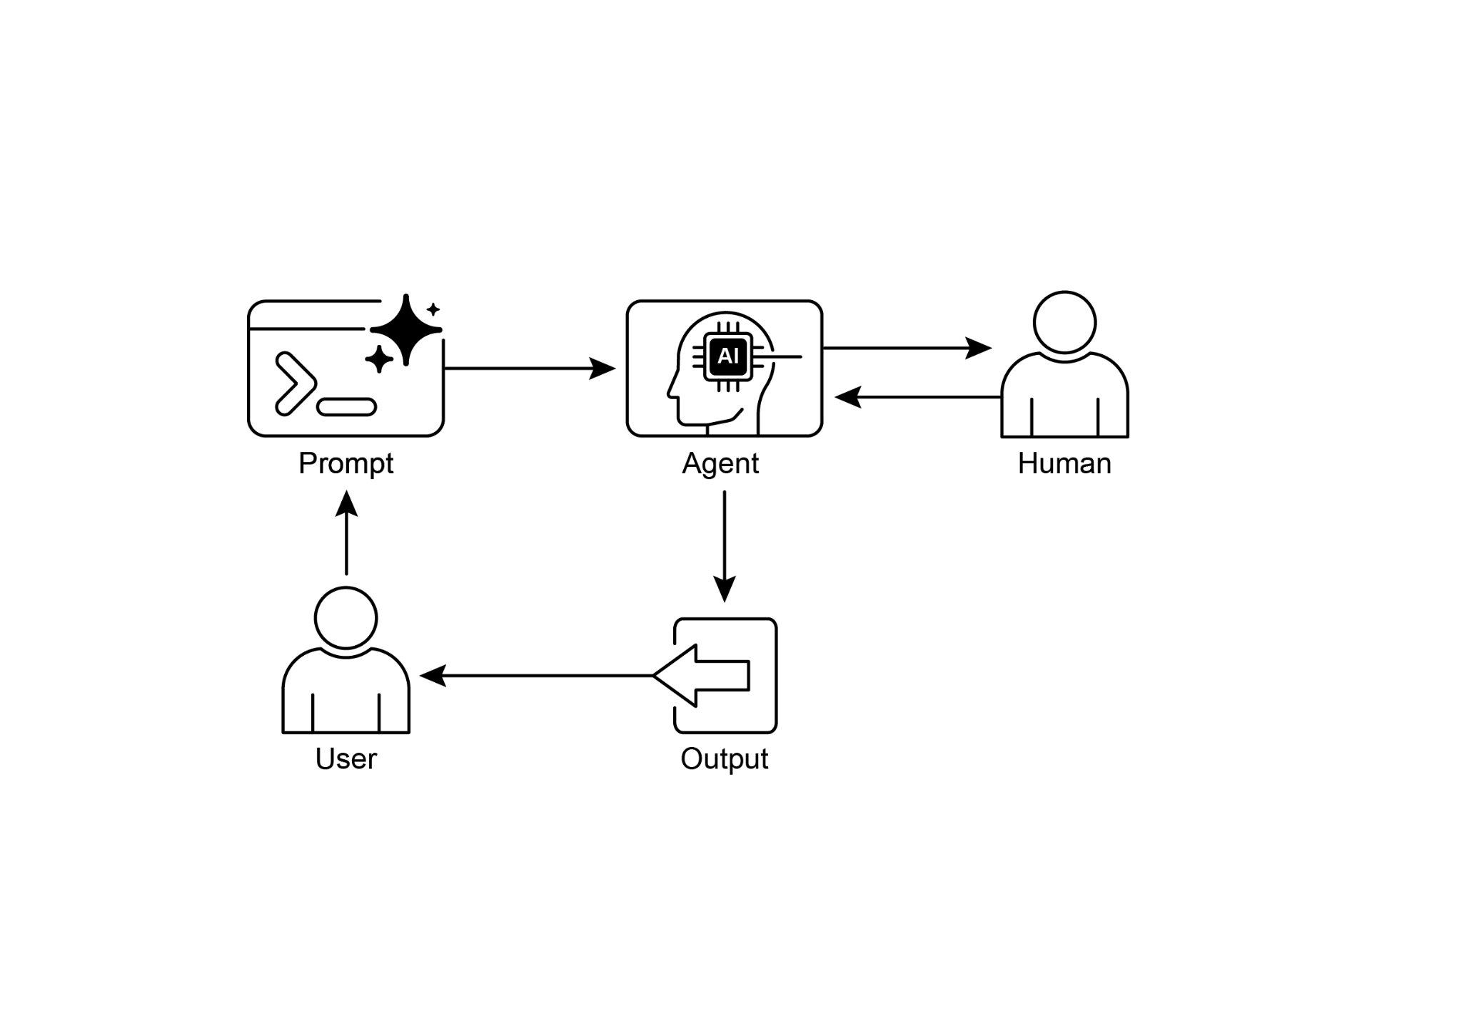

Fig.1: Human in the loop design pattern

# Key Takeaways

Key takeaways include:

* Human-in-the-Loop (HITL) integrates human intelligence and judgment into AI workflows.
* It's crucial for safety, ethics, and effectiveness in complex or high-stakes scenarios.
* Key aspects include human oversight, intervention, feedback for learning, and decision augmentation.
* Escalation policies are essential for agents to know when to hand off to a human.
* HITL allows for responsible AI deployment and continuous improvement.
* The primary drawbacks of Human-in-the-Loop are its inherent lack of scalability, creating a trade-off between accuracy and volume, and its dependence on highly skilled domain experts for effective intervention.
* Its implementation presents operational challenges, including the need to train human operators for data generation and to address privacy concerns by anonymizing sensitive information.

# Conclusion

This chapter explored the vital Human-in-the-Loop (HITL) pattern, emphasizing its role in creating robust, safe, and ethical AI systems. We discussed how integrating human oversight, intervention, and feedback into agent workflows can significantly enhance their performance and trustworthiness, especially in complex and sensitive domains. The practical applications demonstrated HITL's widespread utility, from content moderation and medical diagnosis to autonomous driving and customer support. The conceptual code example provided a glimpse into how ADK can facilitate these human-agent interactions through escalation mechanisms. As AI capabilities continue to advance, HITL remains a cornerstone for responsible AI development, ensuring that human values and expertise remain central to intelligent system design.

# References

1. A Survey of Human-in-the-loop for Machine Learning, Xingjiao Wu, Luwei Xiao, Yixuan Sun, Junhang Zhang, Tianlong Ma, Liang He, <https://arxiv.org/abs/2108.00941>